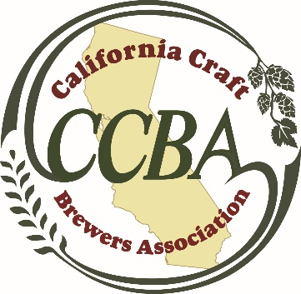

FOR IMMEDIATE RELEASE CONTACT: Leia Ostermann
October 2, 2015 Perry Communications Group
leia@perrycom.com
(916) 658-0144

Craft Brewers Can Now Communicate Retail Information on Social Media
California Craft Brewers Association Applauds Governor Brown for Signing AB 780
SACRAMENTO, Calif. (October 2, 2015) – Tom McCormick, executive director of the California Craft Brewers Association (CCBA), issued the following statement today in response to Governor Jerry Brown signing Assembly Bill 780, authored by Assembly Member Das Williams (D-Santa Barbara).
“AB 780 is great news for craft enthusiasts in our state who are hungry for information about their favorite beers. The bill allows craft breweries in California to communicate product availability information to their fans on social media, including where to purchase specialty beers at local stores and restaurants. This is an exciting development for CCBA’s brewery members who use social media regularly to communicate with fans and potential customers.
“More than ever, California’s craft beer drinkers are looking to their favorite breweries for information about special releases or where to purchase their favorite craft beer at a local retail location. Prior to AB 780, a brewery could only communicate product availability after a direct inquiry from a customer. AB 780 removes the requirement for a formal request and allows for better communication between breweries and their fans, as long as two or more retail locations are included in the social media post.
“This year has been marked by tremendous growth and support for the craft beer industry in California. The industry contributed $6.5 billion to the state economy last year and now boasts nearly 600 craft breweries, more than any other state in the nation. CCBA members appreciate the support of Gov. Brown and Assembly Member Das Williams and look forward to the continued growth of craft beer in California.”
About California Craft Brewers Association
The California Craft Brewers Association is a 501(c)6 non-profit trade association protecting the political and legal rights of the California craft brewing industry. The association was formed in 1989 and is the oldest state craft brewers’ trade association in the country To learn more about the craft beer industry in California, please follow California Craft Brewers Association on Instagram, Twitter and Facebook or online at www.californiacraftbeer.com.
###

