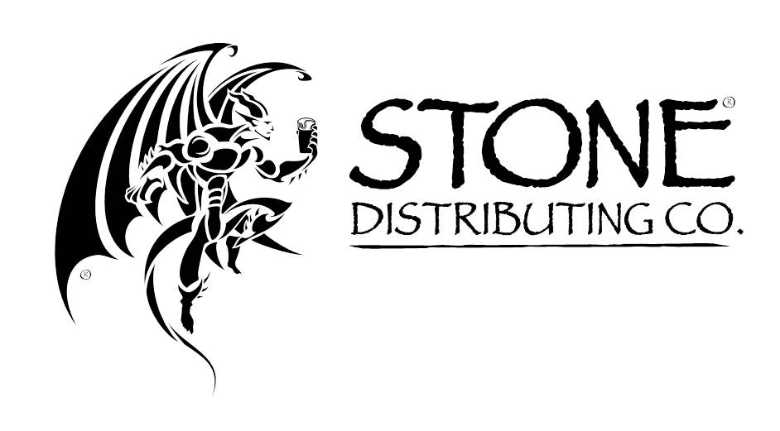
Delivery Instructions to Downey DC

E-mail Address for Dock Appointments Phone # for Dock Appointments
DC-LA@stonebrewing.com (760)-294-7899 EXT 1378 OR 1587

Downey Distribution Center
7475 Flores Street
Downey, CA 90242

Business Hours: Monday through Friday, 8am – 5pm

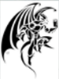
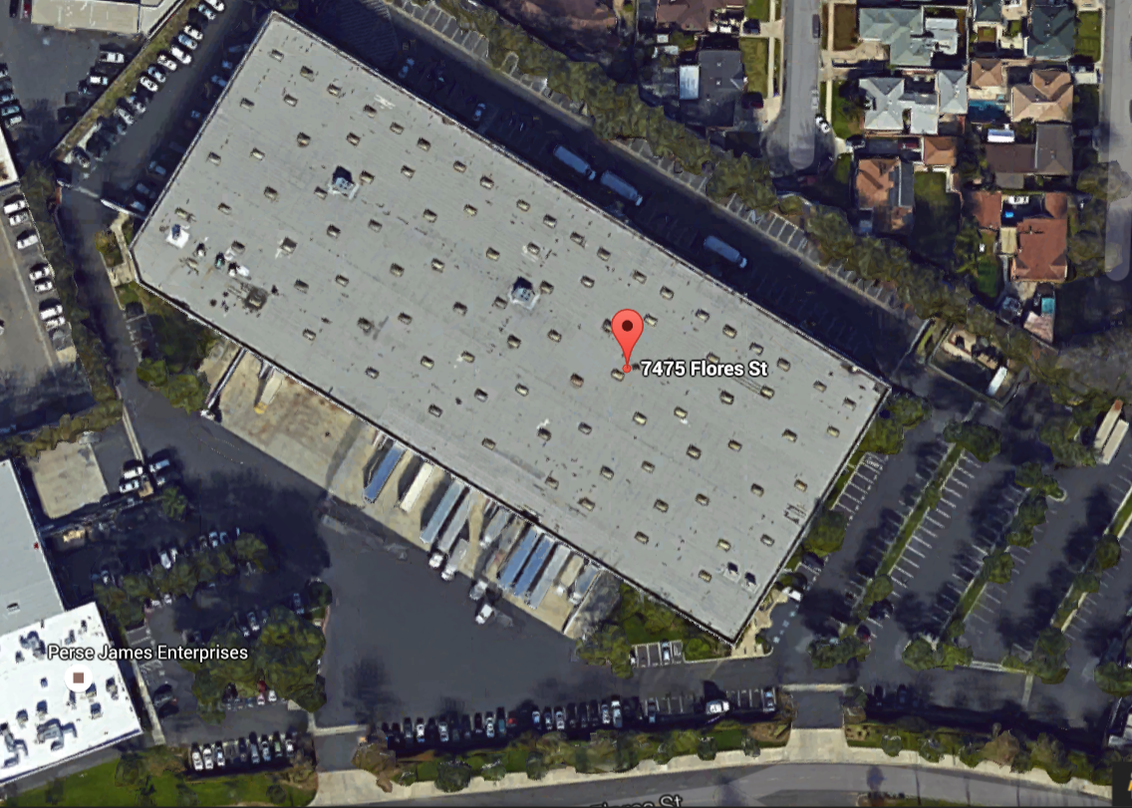

To make deliveries please e-mail or call DC to schedule an appointment. Contact info is provided above. When contacting, please provide the following info: exact name of event you’re delivering beer for, your brewery or company name, quantity and description of items (kegs, cases, POS, etc.) you’re delivering, and day you’re requesting to deliver on. If contacting via e-mail, put name of event in the subject line and the rest of the info in the body of e-mail. If contacting via phone and no one answers, please leave message with all required info and a contact number we can call back. A Warehouse Manager, Supervisor, or Lead will respond to all e-mails, phone calls, and voicemails within business hours. If making delivery with delivery truck, an actual dock appointment will need to be made. If delivering with personal vehicle, just a scheduled delivery day will be made. When making delivery with personal vehicle, please park in designated parking spots per picture above. The arrow indicates where there are 3 clearly marked designated parking sports for pick-ups and deliveries as well as the door you will need to knock on when you arrive. You may also call provided contact number and notify us of your arrival.

