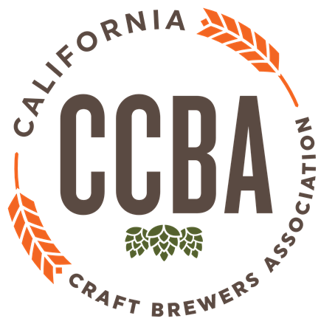

Proposition 65 was enacted as a ballot initiative in November 1986. The proposition requires businesses to inform Californians about exposure to chemicals that may cause cancer, birth defects or other reproductive harm. After the initiative passed, breweries in California were required to provide alcohol beverage warning signs to warm of the potential harm of alcohol consumption. These signs are distributed to all retailers of alcohol by an independent company paid by the CCBA and other industry associations.

In 2015, bisphenol A (BPA) was added to the Prop. 65 list of chemicals. Since the alcohol beverage signs currently being distributed and displayed only cover alcohol and not specific chemicals, an additional warning is required to cover BPA. BPA is found in the plastic/rubber linings in cans and in some bottle crowns and growler caps. Currently, regulators have not provided a maximum allowable dose level (MADL) for BPA, so even minute traces of BPA require a warning. Check with your supplier to see if the cans, crowns or lids you are using contain BPA. Many manufacturers have already switched over to a non-BPA material called BPANI.

Starting in May of 2016, warnings were required for any product that caused exposure to BPA. Any manufacturer of products that are packaged in containers with BPA linings or seals must provide a “clear and reasonable” warning to the consumer in order to have immunity from lawsuits (referred to as “safe harbor”).

To allow manufacturers the opportunity to find BPA-free materials, the Office of Environmental Health and Hazard Assessment (OEHHA) issued emergency regulations which allowed an alternate and temporary means of consumer notification by providing an online database in which those products containing BPA could be listed. Those emergency regulations expire December 30, 2017.

It is currently unclear exactly how brewers will be able to meet a “clear and reasonable” standard of consumer warning come December 31, 2017. OEHHA is suggesting either a warning on the package itself or a “SKU-specific” warning at the point-of-purchase. SKU-specific would require that each product on the shelf have a warning directly under each individual SKU placement of all products containing BPA. This would be nearly impossible logistically given the dynamics of the retail beer set and it is unclear how this would be satisfied at on-premise retail accounts.

Please note a small business with less than 10 full time employees is exempt from all Prop. 65 requirements, including BPA warning requirements. All other breweries will need to prepare for a rapid compliance timeline to achieve “safe harbor” before the end of 2017.

What’s Next?

The CCBA continues to be actively engaged in this issue to seek clarification and reasonable interpretation of the law for our members. The CCBA will issue guidance as soon as the specific requirements are known. In the meantime, it’s important for brewery owners in California to:
- Contact their supplier to see if crowns, cans or lids you are using contain BPA. If they do not, request written documentation from your supplier. If they do, ask if there are BPANI or alternate BPA-free products you can purchase. Keep CCBA updated if your supplier has already switched to all BPA-free products.
- Stay connected with the CCBA Weekly Bulletin. We will issue guidance as soon as possible, following the conversations occurring with OEHHA, the Governor’s office and other industry stakeholders to seek a resolution.
- Be prepared to react quickly to potential requirements to remain in “safe harbor” against public lawsuits prior to January 1, 2018.

