Thank you for being part of the 2019 Summit Beer Festival. The Beer Fest is the grand finale of the Summit Weekend! There will be over 170 breweries in attendance pouring their beer at Marina Green Park and the outdoor festival will highlight California beers only!
Here is quick overview of the event and some FAQs that will hopefully answer all your questions regarding the event:
Event Date: Saturday, September 14, 2019
Event Location: Marina Green Park, 386 E Shoreline Dr., Long Beach CA
Event Time: 12 PM -5 PM
Main On-site Contact: A name and phone number will be provided in August via email.
Email: beer@cacraftbeersummit.com
Brewery Set-Up Time: 8:30am- 11am
All set-up completed; no vehicles allowed in the area after 11 am
- Festival VIP Hour Opens/First Pour: 12 PM
- Festival General Admission Opens: 1 PM
- Last Call: 4:50pm
- Festival Ends: 5pm-Load out will begin immediately after all attendees have vacated the Mall. Possible delays due to high volume move out.
Brewery Load-In Location (MAP):
Enter venue from Linden Avenue at Shoreline Drive. Take an immediate right into the parking lot where you will see our Summit check in sign.
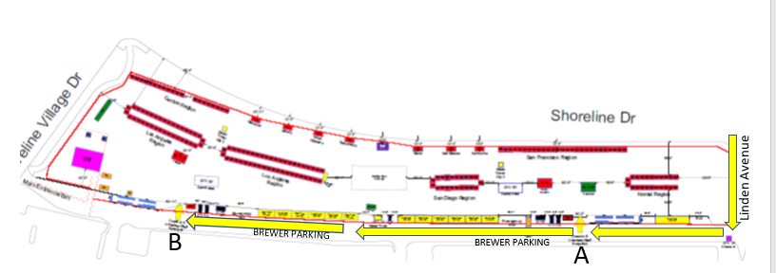STEP-BY-STEP LOAD-IN INSTRUCTIONS:
- Brewers must check in and receive a parking pass for their vehicle
- All traffic will be one way from the check point on
- Brewers will be directed to Zone A or B check in whichever is closest to their tent location. There will be an opening in the fence line at that point.
- You can pull up to that zone check in and off load your beer for volunteers to take to your tent; Or you can pull into a parking spot in your zone and unload and hand cart your beer in through your zone entrance.
- Display your parking pass on your dashboard clearly
- If parking in the lot is full you will be asked to circle around the park and be routed into our parking on the unused grass portion of marina green park – exact instructions will be given upon arrival at the Linden Check point.
Brewery Parking: Limited parking spots will be reserved for brewers loading in (see above map and step by step instructions for where to park with your Summit parking permit).
For additional brewery staff parking, multiple parking garages and lots near Marina Green Park can be viewed here.

Brewery Load Out:
Brewers with personal vehicles:
- Brewers can hand carry their equipment to their cars; or they can wait for assistance from the beer team to shuttle them on golf carts to their vehicles
- If you do not take your kegs/equipment it will be put on the Stone truck and sent to the Stone Downey location for pick up
- Once you are loaded PLEASE EXIT ONTO SHORELINE VILLAGE DRIVE.
Using a Distributor:
- SET UP/ BEER DROP OFF: Beer will be dropped between 7:30am - 9:30am at your booths and will be available for set up between 9:30am – 11:00am
- LOAD OUT: All breweries who are with a distributor will be asked to leave their beer in their booth for pick up. CCBA staff will assist in returning beer to the distributor on-site after the festival.

CCBA will be providing brewers with the following:
- 10 x 10 Tent (DO NOT BRING YOUR OWN)
- Standard event signage with your brewery’s name to go on the tent
- 8 ft table
- 2 chairs
- ONE 20 gal. Keg Bucket
- Ice
- Dump bucket
- *** CCBA will be providing the ABC Non-Profit Temporary One-day License to all breweries at each table)
Brewers will need to provide:
- Jockey box equipment
- Table Cloth (CCBA will provide a table cloth if you are not able to)
- Please feel free to bring additional signage/ decor for your table and to put up around your booth

ADVANCED Beer Drop Off Points: Chico, Escondido & LA
CCBA has drop three drop off points at Sierra Nevada Brewing Co, Stone’s Facility in Escondido, and Stone’s Facility in Downey
Detailed instructions and drop-off dates for each facility drop off location located here.

Dropping off at the Long Beach Convention Center: 9/11, 9/12 & 9/13
CCBA will let brewers drop of their festival beer at the Long Beach Convention Center Loading dock from 9/11-9/13
Drop Off Times: Wed. 9/11: 2:00pm-6:00pm; Thurs. 9/12: 8:00am-5:00pm; Fri. 9/13: 8:00am- 5:00pm

FAQs
How many passes do I get as a participating brewery?
As a participating brewery you receive 4 complimentary Summit Brewery passes, getting access to all the weekend events! Use your personalized access code to redeem your passes on the eventbrite website, where it says 'enter promotional code.' Contact the CCBA offices at (916) 228-4260 to receive your code.
What’s included with the Brewery Pass?
This is your golden ticket to the Summit weekend- you and your brewery staff will have an all access pass to each event!
- All access to the Summit Expo Hall (Thursday & Friday)
- Access to all Educational sessions- Check out the talk schedule here
- Access to the Saturday’s Summit Beer Festival
- Access to all the Friday night CCBA 30th anniversary reception
Why should I attend the Summit Expo Hall at the Long Beach Convention Center?
Because this is “Your” show! It is for you, about you, with you, to promote you – IT IS the story of California Craft Beer! It is “your story”! Help us tell it!
Inside the Long Beach Convention Center, the Summit Expo Hall will feature:
  - Demos and displays on everything craft beer
  - Educational Seminars! Great education for your staff- view the schedule here
  - Trade show with industry exhibitors
  - “Tap Talks” with the leaders in the craft beer industry. See our headliner list!
  - There will also be regional beer tasting areas
If I need additional volunteers at my festival booth who should I contact?
If only one staff member is attending to pour at your booth please email beer@cacraftbeersummit.com and request an additional volunteer to help
Is there a hotel room group discount?
CCBA has a discounted group room rate at the Sheraton Hotel Grand and other nearby hotels in downtown Sacramento. Please book early, link here.

